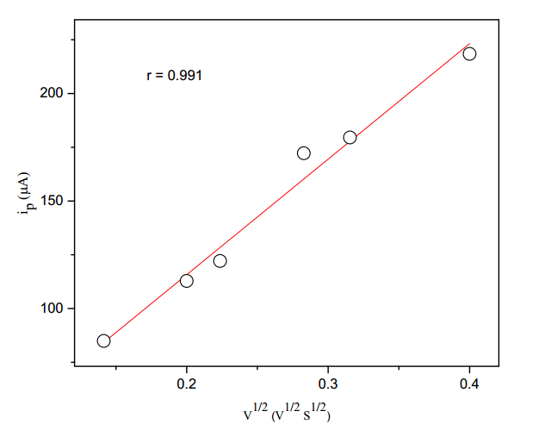

Fig.6. Plot of second peak current (ip) versus square root of sweep rate for the

electrolytic reduction of (E)-1-(furan-2-yl)-3-phenylprop-2-ene-1-ones in tetra butyl

ammonium tetra fluoroborate.

Solvent = acetonitrile.